Test specification for

DP*K06 & DPF*(K/M)00-

# History

Prev.vers. Release Description of changes

A 11.06.2008 Document created.

B 02.03.2015 DPF2K and DPF3K added to the document.

C 16-12-2015 Functional test specification for 7766 added

Test specification for DPAK and DPBK merged into this UE doc.

D 08-02-2018 DPH1K, DPH2K and DPH3K

E 2018-12-03 DPF1K00-0005 w. 3 pole connector added.

F 2020-07-31 Test/log description in section 4 changed for ease of understanding

G 2021-12-15 Added SMLDPF2K00-0004-00-A under section 6 (last page)

H 2022-01-14 Removed SMLDPF2K00-0004-**00**-A (Discontinued)

# Contents

History 1

Contents 2

1. Purpose 3

2. Validity 3

3. Functional test specification – supplier no. 7314 4

3.1 Test setup 4

4. Functional Test specification – other suppliers 5

4.1 Test setup 5

4.2 PC Software 5

4.3 Log file 5

4.4 Functional Test steps 5

4.4.1 Short circuit detection 6

4.4.2 Button activation detection 6

5. Pin description and color code for plug 7

6. Plug terminal description and color code 8

6.1 DPF1K00-*****6, DPAK06, DPBK06 8

6.2 DPF2K00-*****6 8

6.3 DPF3K00-*****6 8

6.4 DPF1M00-*****6 8

6.5 DPF1K00-0005-* 8

6.6 SMLDPF2K00-0004-00-A 9

# Purpose

To describe functional test of assembled Desk Panels listed in next section.

# Validity

Valid for the following variants of variants:

DPF1K00-*****6

DPF2K00-*****6

DPF3K00-*****6

DPF1M00-*****6

DPAK06

DPBK06

# Functional test specification – supplier no. 7314

Desk Panels can be tested in a simple way, by testing that the desired function is achieved by short-circuiting the respective wires in desk panel.

A set of LED’s can be used as an output test result indicator.

## Test setup

Figure below shows the proposed test setup. One DPF can be tested at a time.

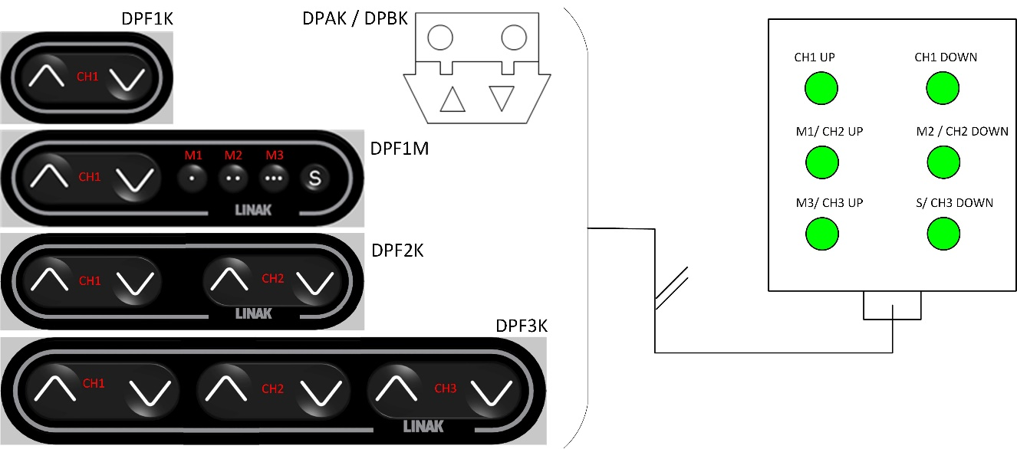

# Functional Test specification – other suppliers

The purpose of the test is to measure if the DP is functioning as purposed and to see that no short circuit is measured when not button is activated.

## Test setup

A very simple test setup where the DP is connected to a measurement device through the RJ45 plug. A PC software is used as a user interface.



## PC Software

A simple PC software should indicate if the DP has passed or failed the test.

## Log file

The tester should log all test results for each item tested. Each row should contain logs for an item tested, containing barcode content, date, measured value for each step, and the final test result. The header among other should contain test number or title with test limits for each test step. The log file type may be a csv. file.

Log file name format should be YYWWpppppppp:

Where: YY = Year

WW = week

pppppppp = purchase order number

Log file example:

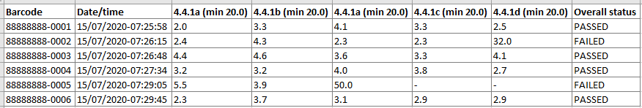

## Functional Test steps

The test program must execute the each test step for the specific variant. If an item fails the test, the user should be informed visually by red screen, and if possible also audibly. If all test steps are completed (with no failure) the PC interface must turn green to indicate that the DP has passed the test. The green color must remain until the DP is disconnected and then it must return to original color.

In the table below, there is an overview of which tests should be carried on the different variants:

|  |  |  |  |  |
| --- | --- | --- | --- | --- |
| **Test step** | **Description** |  |  |  |
| 4.4.1 | Short circuit detection | DPF1K  DPAK  DPBK  DPH1K | DPF2K, PH2K | DPF1M, DPF3K  DPH1M |
| 4.4.2 | CH1 up activation |
| 4.4.3 | CH1 down activation |
| 4.4.4 | CH2 up / M1 activation |  |
| 4.4.5 | CH2 down / M2 activation |
| 4.4.6 | CH3 up / M3 activation |  |
| 4.4.7 | CH3 down / S activation |

After the DP is connected to the tester, the following test steps must be executed in the listed order:

### Short circuit detection

If no button activation, no short circuit between the RJ45 plug pins should be measured. Following pins should be measured:

|  |  |  |  |  |  |  |  |  |
| --- | --- | --- | --- | --- | --- | --- | --- | --- |
| **Test step** | **Measure point A** | **Measure point B** | **Target value** | **Min** | **Max** |  |  |  |
| 4.4.1a | Red (Pin 8) | Green (Pin 5) | - | 20 MΩ | - | DPF1K  DPAK  DPBK | DPF2K | DPF1M, DPF3K |
| 4.4.1b | Red (Pin 8) | Blue (Pin 4) | - | 20 MΩ | - |
| 4.4.1c | Green (Pin 5) | Blue (Pin 4) | - | 20 MΩ | - |
| 4.4.1d | Red (Pin 8) | White (Pin 3) | - | 20 MΩ | - |  |
| 4.4.1e | Green (Pin 5) | White (Pin 3) | - | 20 MΩ | - |
| 4.4.1f | Blue (Pin 4) | White (Pin 3) | - | 20 MΩ | - |
| 4.4.1g | Red (Pin 8) | Orange (Pin 2) | - | 20 MΩ | - |  |
| 4.4.1h | Green (Pin 5) | Orange (Pin 2) | - | 20 MΩ | - |
| 4.4.1i | Blue (Pin 4) | Orange (Pin 2) | - | 20 MΩ | - |
| 4.4.1j | White (Pin 3) | Orange (Pin 2) | - | 20 MΩ | - |

### Button activation detection

When a button is activated, a short circuit should be measured between below listed pins in RJ45 plug:

|  |  |  |  |  |  |  |  |  |  |
| --- | --- | --- | --- | --- | --- | --- | --- | --- | --- |
| **Test step** | **Test name** | **Measure**  **point A** | **Measure**  **point B** | **Target** | **Min** | **Max** |  |  |  |
| 4.4.2a | CH1 up | Green (Pin 5) | Blue (Pin 4) | 0 Ω | 0 Ω | 2 Ω | DPF1K  DPAK  DPBK | DPF2K | DPF1M, DPF3K |
| 4.4.2c | CH1 down | Red (Pin 8) | Blue (Pin 4) | 0 Ω | 0 Ω | 2 Ω |
| 4.4.2d | CH2 up /  M1 | Green (Pin 5) | White (Pin 3) | 0 Ω | 0 Ω | 2 Ω |  |
| 4.4.2f | CH2 down / M2 | Red (Pin 8) | White (Pin 3) | 0 Ω | 0 Ω | 2 Ω |
| 4.4.2g | CH3 up /  M3 | Green (Pin 5) | Orange (Pin 2) | 0 Ω | 0 Ω | 2 Ω |  |
| 4.4.2j | CH3 down / S | Red (Pin 8) | Orange (Pin 2) | 0 Ω | 0 Ω | 2 Ω |

# Pin description and color code for plug

Following describes the color code / terminal numbering of different functions for testing purposes.

|  |  |
| --- | --- |
| Plug 8P. | |
| Plug 8P Pin No. | Wire color |
| 1 | - |
| 2 | Orange |
| 3 | White |
| 4 | Blue |
| 5 | Green |
| 6 | - |
| 7 | - |
| 8 | Red |

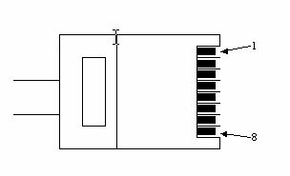

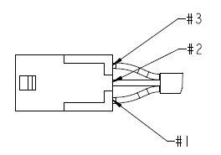

|  |  |
| --- | --- |
| Plug 3P. | |
| Plug 3P Pin No. | Wire color |
| 1 | Blue |
| 2 | Green |
| 3 | Red |

# Plug terminal description and color code

## DPF1K00-*****6, DPAK06, DPBK06

|  |  |  |
| --- | --- | --- |
| **Cable color code** | **DPF function** | **Plug 8P Pin No.** |
| Blue+Green | 1 Up | Pin 4+5 |
| Blue+Red | 1 Down | Pin 4+8 |

## DPF2K00-*****6

|  |  |  |
| --- | --- | --- |
| **Cable color code** | **DPF function** | **Plug 8P Pin No.** |
| Blue+Green | 1 Up | Pin 4+5 |
| Blue+Red | 1 Down | Pin 4+8 |
| White+Green | 2 Up | Pin 3+5 |
| White+Red | 2 Down | Pin 3+8 |

## DPF3K00-*****6

|  |  |  |
| --- | --- | --- |
| **Cable color code** | **DPF function** | **Plug 8P Pin No.** |
| Blue+Green | 1 Up | Pin 4+5 |
| Blue+Red | 1 Down | Pin 4+8 |
| White+Green | 2 Up | Pin 3+5 |
| White+Red | 2 Down | Pin 3+8 |
| Orange+Green | 3 Up | Pin 2+5 |
| Orange+Red | 3 Down | Pin 2+8 |

## DPF1M00-*****6

|  |  |  |
| --- | --- | --- |
| **Cable color code** | **DPF function** | **Plug 8P Pin No.** |
| Blue+Green | 1 Up | Pin 4+5 |
| Blue+Red | 1 Down | Pin 4+8 |
| White+Green | M1 | Pin 3+5 |
| White+Red | M2 | Pin 3+8 |
| Orange+Green | M3 | Pin 2+5 |
| Orange+Red | S | Pin 2+8 |

## DPF1K00-0005-*

|  |  |  |
| --- | --- | --- |
| **Cable color code** | **DPF function** | **Plug 3P Pin No.** |
| Blue+Green | 1 Up | Pin 1+2 |
| Blue+Red | 1 Down | Pin 1+3 |